# ../Pictures/Photos%20Library.photoslibrary/resources/proxies/derivatives/68/00/6801/VzEiuvKRTM+Xw02XbsnMKA_thumb_6801.jpg

# 3D Printing Experiences – finishing a project in style

An MP Select Mini 3D printer (link is the latest toy that I purchased along with fellow Maker and whatImade.today (link <http://whatimade.today/> ) associate Michael Diamond (link <http://whatimade.today/author/miked/> ) We selected this entry level printer that came preassembled, easy to operate and inexpensive. The Amazon.com price for an MP Select Mini 3D Printer (link <https://www.amazon.com/Monoprice-Select-Printer-Heated-Filament/dp/B01FL49VZE> ) was just too good to pass up – about $220. I’ve spent more on soldering iron in the past!

Mike and I have been busy printing lots of gadgets, toys, Raspberry Pi enclosures and geared objects. We are having a ball! Designing and printing 3D objects is so much fun.

Today, I am telling you about my own 3D-printing experiences.

## Finishing an Arduino Project – 3D Printing an Enclosure

My first practical device to print was an Arduino enclosure. This allowed me to complete a previously-built Arduino Project, the Time/Date/Temperature display device, blogged here (link <http://whatimade.today/programming-an-8-digit-7-segment-display-the-easy-way-using-a-max7219/> ).

The case is comprised of two pieces, an enclosure back, and an enclosure front with cutouts and mounting holes for 3 subassemblies:

* An Arduino Nano
* The 8-digit 7-segment display
* The RTC / Temperature module

To build this box, I followed these steps:

First, I imagined the enclosure, sized to fit the three subassemblies:



|  |  |  |  |
| --- | --- | --- | --- |
| ***Item*** | ***Overall size*** | ***Cutout size*** | ***Mounting holes*** |
| Arduino Nano | 43 mm x 17 mm | button/leds: 19 x 13  Power plug: 10 x 7 | *None* |
| 8-digit display | 82 mm x 15 mm | 63 mm x 16 mm | 4 mm |
| RTC module | 38 mm x 21 mm | 19 mm x 21 mm | 2.5 mm |

About 10 mm of space was left between all components. You need space for wiring and space for the components to breathe! From these dimensions, we can see that we need an overall enclosure size of 100mm x 60mm.

There are a number of different programs one can use to 3D design. Mike and I are using Autodesk’s Tinkercad, which is an easy and free version of the well acclaimed Autodesk Fusion 360 program. The advantages of Tinkercad are:

* It’s cloud-based, accessible by your browser
* It’s easy to learn and use
* Large 3D printer userbase
* Plenty of tutorials on YouTube
* You can share your designs and tinker with other makers’ designs
* It’s free

Its quite easy to get started. Go to [www.tinkercad.com](http://www.tinkercad.com) (link). Clink on “SIGN UP” and create your account. Click on LEARN and follow the brief lessons. You can jump in and start designing right away.

We create the Enclosure Front in Tinkercad as follows:

* Open up a new workspace by clicking “CREATE NEW DESIGN”.
* Select a Box and Lid object from the Featured Shape Generators palette. Drag it onto the Workplane.
* Specify the Box Length 100, Width 60, Height 10, and Box Top in the Shape customizer window.
* Begin making the rectangular cutouts. (there was a lesson on cutouts in the tutorial). Because the box top is face down on the drawing plane, you actually have to imagine all the boards upside down and mirrored (left to right). This is a fun challenge.
* Make cutouts and standoffs as appropriate for the 3 boards.
* Make standoffs appropriate for the Nano and the RTC board.
* Virtually drill mounting holes
* The design should look something like this:



You can download my design here (link <https://www.tinkercad.com/things/7AdeuZsgUO7-nano-8-digit-enclosure-front> )

Finally print this object, the Enclosure Front. I used the settings for PLA:

Layer height 0.2 mm

default shell thickness, top/bottom thickness

Fill density 20%

default print speed

Printing Temperature 200° C

Here is a picture of my test print, done with a print-fineness of 0.2mm, so it can be done quickly.



We make a few small modifications to the model and print the final object at a print-fineness of 0.1mm.

Now, it’s time to assemble. With this technique, the boards are not attached to a PCB but directly to the enclosure. You have to remove (desolder) all of the headers and side connectors.

A good way to remove an unwanted header pin is to set your soldering iron on high (400° C) and then heat up the pin. In one sharp motion, whack the board on the edge of your work table with a solid metal garbage can underneath. The pin and all the excess solder should fly off of the board.

Once the boards are clean of unwanted pins, its time to preassemble.

Place the RTC board and the 8-digit display in this enclosure. Attach with 3mm x 8 and 2.5mm x 8mm machine screws.



Prewire the Arduino outside of the enclosure, solder the 5 wires for the Display connection and the 4 wires for the RTC connection – just on the Arduino.

|  |  |  |
| --- | --- | --- |
| ***Signal name*** | ***Arduino*** | ***7-segment Display*** |
|  | +5v | VCC |
|  | GND | GND |
| DIN | D4 | DIN |
| CS | D5 | D5 |
| CLK | D6 | CLK |
|  |  |  |
|  | ***Arduino*** | ***RTC module*** |
|  | nc | 32K |
|  | nc | SQW |
| SCL | SCL/A5 | SCL |
| SDA | SDA/A5 | SDA |
|  | 3v3 | VCC |
|  | GND | GND |

It’s a good idea to label all data wires and color coded all power and ground wires, as I have done in the photo below.

Insert the Arduino Nano. Now solder the wires to the RTC module, then the Display module.

After the entire assembly is functioning as designed, the Nano can be hot-glued into position on little mounting tabs in each corner.

I wired this project three times. Once with stranded wires but that didn’t work out.

The second time with 24gauge solid wires but the wires were trimmed too short.

The 3rd time was the charm:

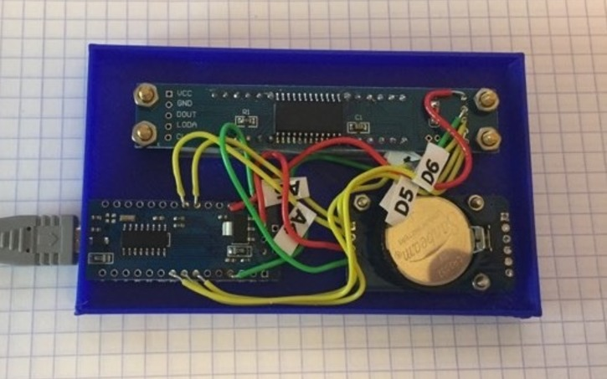

.

Next, we adapt and test the Arduino code:

In this case, I copied the code from my pre-existing project. I made some small port-assignment changes, just for the convenience of wiring.

In addition, I made one rather interesting improvement. The RTC is automatically set from the compile time of the Arduino code. This is possible because the Mac Book I am running the Arduino IDE on has the accurate and correct time and the process of Upload recompiles the code. The compile time constants of \_\_TIME\_\_ and \_\_DATE\_\_ are set by the compiler and accessible from your code. Here is the code:

// ... set the RTC date and Time to the compile date and time

void set\_RTC\_to\_compile\_time()

{

const char time\_now[] = \_\_TIME\_\_; // hh:mm:ss

Serial.print("compile time: "); Serial.println(time\_now);

int hh = atoi(&time\_now[0]);

int mm = atoi(&time\_now[3]);

int ss = atoi(&time\_now[6]);

Serial.println("hh: " + String(hh) + " mm: " + String(mm) + " ss: " + String(ss));

rtc.setTime(hh, mm, ss); // Set the time to the compile time (24hr format)

const char date\_now[] = \_\_DATE\_\_; // Mmm dd yyyy

const char \*months[] = {"Jan", "Feb", "Mar", "Apr", "May", "Jun",

"Jul", "Aug", "Sep", "Oct", "Nov", "Dec" };

Serial.print("compile date: "); Serial.println(date\_now);

int Mmm = 0;

for ( int i = 0; i < 12; i++ ) {

if (strncmp(date\_now, months[i], 3) == 0 ) {

Mmm = i + 1;

break;

}

}

int dd = atoi(&date\_now[3]);

int yyyy = atoi(&date\_now[7]);

Serial.println("Mmm: " + String(Mmm) + " dd: " + String(dd) + " yyyy: " + String(yyyy));

rtc.setDate(dd, Mmm, yyyy); // Set the date to dd-Mmm-yyyy

rtc.setDOW(); // Calculate and set Day-of-Week

}

You can download all of the code from here:

( github URL)

Once the code is working as desired, you have should have something that looks like this:

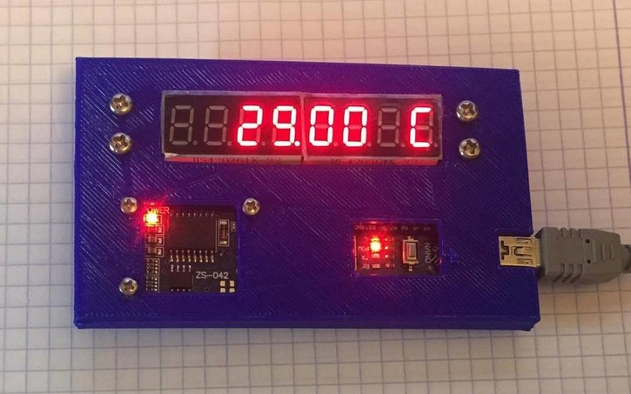

We are almost done. Our enclosure front is complete; the device actually works. We just need the enclosure back.

We design the Enclosure Back in Tinkercad as follows

1. Open up a new workspace by clicking “CREATE NEW DESIGN”.
2. Select a Box and Lid object from the Featured Shape Generators palette. Drag it onto the Workplane.
3. Specify the Box Length 100, width 60, Height 10, and Box Bottom in the Shape customizer window.
4. Make cutouts for air holes. I did this by selecting the Honeycomb object from the Featured Shape Generators palette and dragging it onto the Workplane.
5. I customized it as follows: Hole (*anti-matter*), Radius 4, Rows 5, Columns 9, Minimal Thickness 2.
6. Align the honeycomb pattern, with the Box Bottom, then Group to “drill” these holes.
7. Save



You can download my design here (link <https://www.tinkercad.com/things/42apacBY0sS-nano-8-digit-enclosure-back> )

Finally, print the Enclosure Back. I used the settings:

Layer height 0.1 mm

default shell thickness, top/bottom thickness

Fill density 20%

default print speed

Printing Temperature 200° C

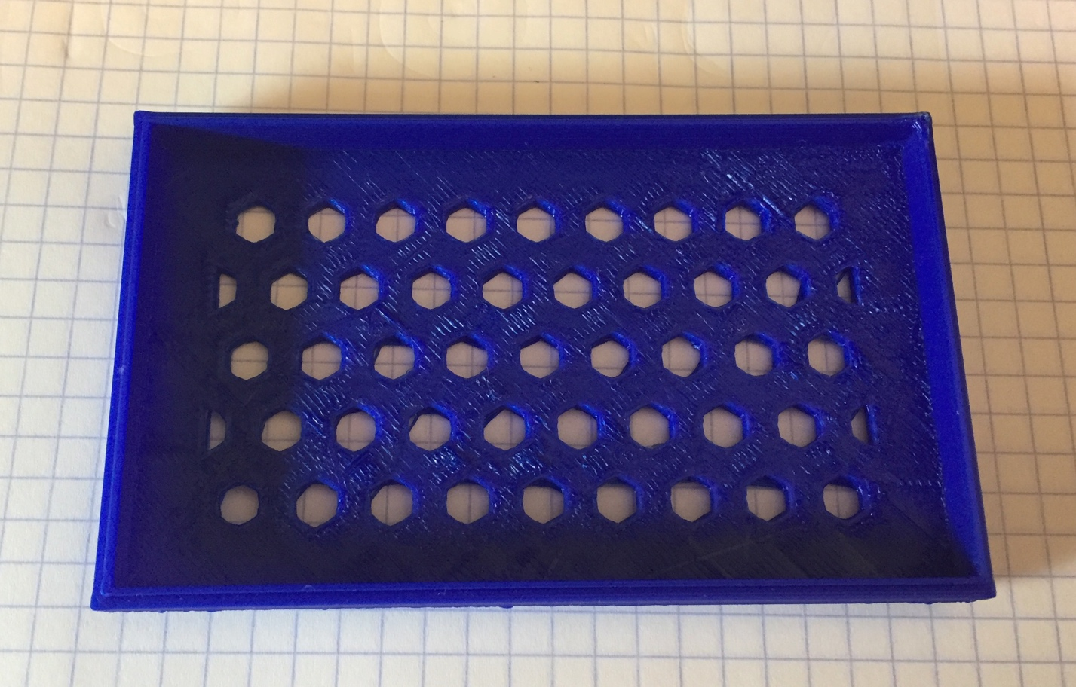

Assemble front to back, (it’s an interference fit (link <https://en.wikipedia.org/wiki/Interference_fit> ),

Here is the finished device--Voila!

